Sovereign states[edit]
List of countries where French is the only official language :
- Benin
- Burkina Faso
- Congo
- DR Congo, the most populated French-speaking country in the world.
- Côte d'Ivoire
- France (Metropolitan France and Overseas France)
- Gabon
- Guinea
- Mali
- Monaco
- Niger
- Senegal
- Togo

Non-sovereign entities[edit]
- French Community
- Geneva
- Jura
- Neuchâtel
- Québec
- Vaud
- Pondicherry

Co-official use[edit]

Sovereign states[edit]
In many countries, French is used as a co-official language alongside one or more other languages. List of countries where French is a co-official language :
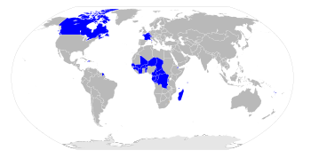
Countries in the world with French as an official language.
- Belgium
- Burundi
- Cameroon
- Canada
- Chad
- Central African Republic
- Comoros
- Djibouti
- Equatorial Guinea
- Haiti
- Luxembourg
- Madagascar
- Rwanda
- Seychelles
- Switzerland
- Vanuatu

Non-sovereign entities[edit]
- Aosta Valley
- Bern
- Brussels
- Fribourg
- Jersey
- New Brunswick
- Northwest Territories
- Nunavut
- Valais
- Wallonia
- Yukon

Officially recognized status[edit]
List of countries and dependency that grant certain constitutional rights to the French language :
- Guernsey
- Lebanon
- Mauritius
- Vatican (Language of diplomacy)

